**COMPUTER INSTITUTE MANAGEMENT SYSTEM**

**INTRODUCTION**

Computer Institute Management System is a software system where the management of the Institute is computerized. The system has different modules for various activities. The various modules of the system are academic details, admission details, daily attendance, staff attendance and admin access, fee details.

The purpose of Computer Institute Management System is to automate the existing manual system by the help of computerized equipment and full-fledged computer software fulfilling their requirements, so that their valuable data can be stored for longer period with easy accessing and manipulation of the same. The required software and hardware are easily available and easy to work with.

Computer Institute Management System, as described above can lead to error free, secure, reliable, and fast management system. It can assist the user to concentrate on their other activities rather to concentrate on record keeping. Thus, it will help organising in better utilization of resources.

The aim is to automate its existing manual system by the help of computerized equipment and full-fledged computer software, fulfilling their requirements, so that their valuable data can be stored for a longer period with easy accessing and manipulation of the same. Basically the project describes how to manage for good performance better services for the clients.

**Operational status**: Is Under Development.

**Undergoing major modification**: Data will be stored in database development.

In this project **MYSQL** is being used as the backend tool for developing and **PYTHON** is being used as frontend tool and for viewing results.

**PROPOSED SYSTEM**

* The proposed Computer institute management system project is very fast and reliable.
* Institute admin can keep close contact with every department of the institute. He has full command over all the modules of software.
* Student daily attendance is maintained on computer. It helps to analyses student progress.
* This project also has an online examination module. Student exams can be taken on computer with this module.
* Question paper can be set for examination. This system provides facility of storing new question in the database.

**DRAWBACKS OF EXISTING SYSTEM**

* Manual entry consumes more time and is difficult to maintain bulk record in manual.
* Not easy to prepare the daily reports.
* Lack of accuracy and error prone.
* Overall efficiency is less.

**BENEFITS OF PROPOSED SYSTEM**

* Secure data
* Faster process
* Error free
* Better management

**System Requirements**

**A. Minimum Software Requirement**

a. Window 7 with Service Pack 1 or Higher Operating System

b. Python 3.6 or any higher version

c. MySQL / SQLite

d. Visual Studio Run Time Environment

e. Dot-Net Framework 3.5 or higher.

**B. Minimum Hardware Requirement**

a) A multimedia Computer with Keyboard and Mouse

b) Processor: Pentium 4 or higher

c) Hard Disk – At least 500 MB free space

d) Memory – 2 GB

**C. Front End Designing Tool** – Python Environment

**D. Back End Tool** – MySQL

**SCREENSHOTS**

RUNTIME

Student Table



Marks Table



Fees Table



Staff Table



Teacher Table



Office Table



TABLE-Structure

STUDENT

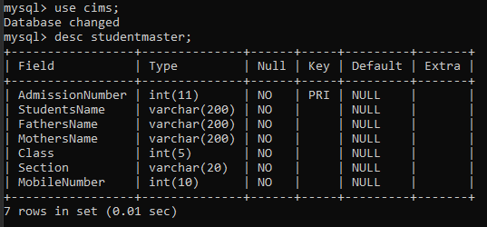

MARKS

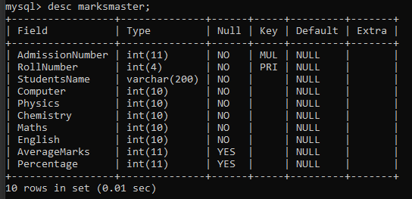

FEES

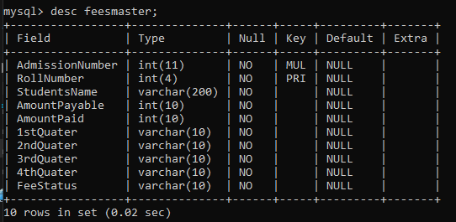

STAFF

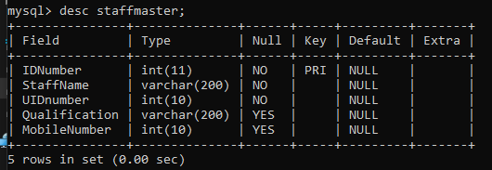

TEACHER

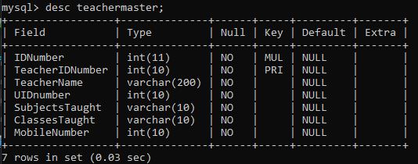

OFFICE

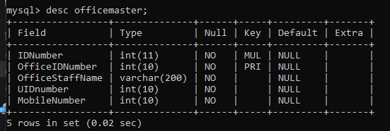

DATABASE

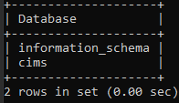

TABLES

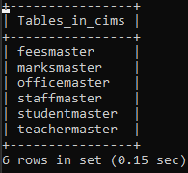

FRONT END-Principal Access

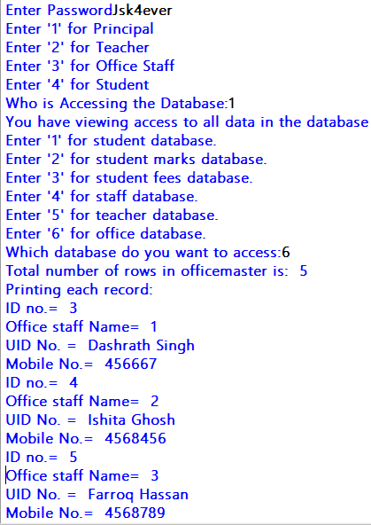

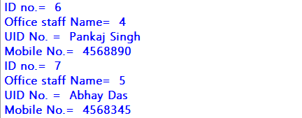

FRONT END-Teacher Access

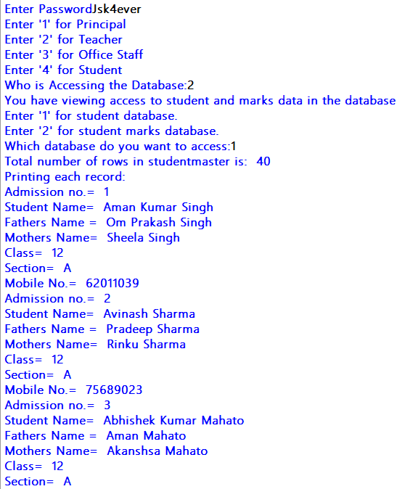

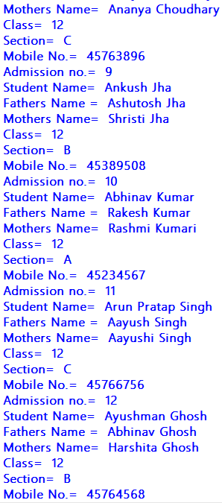

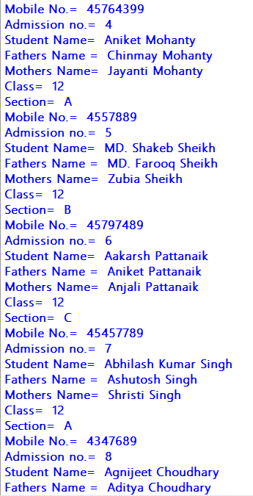

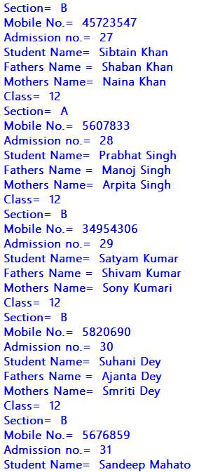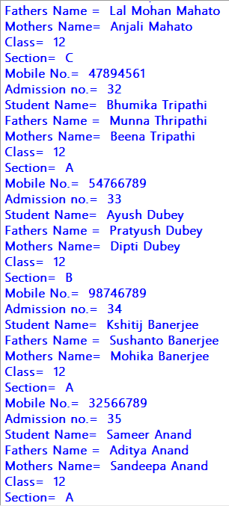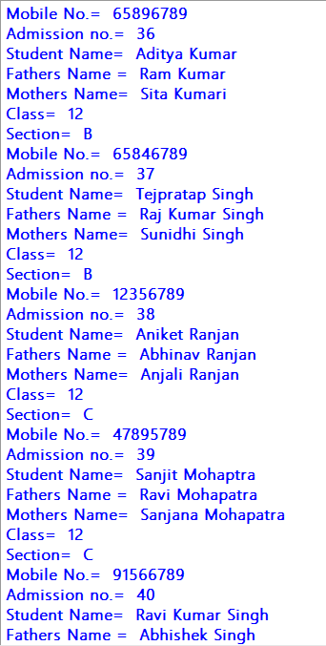

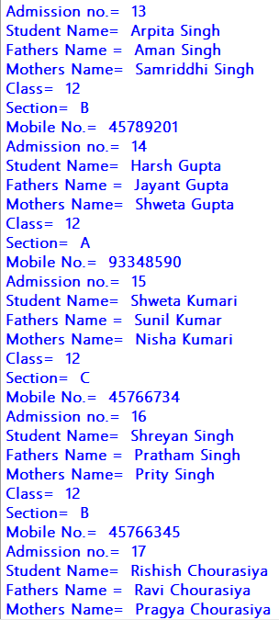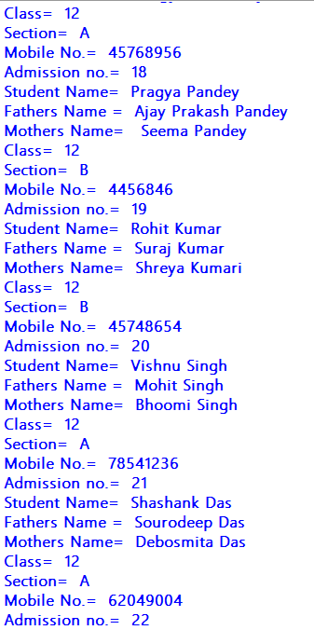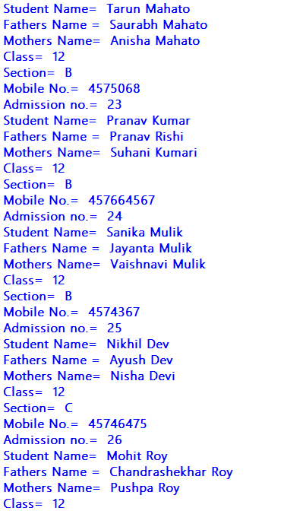

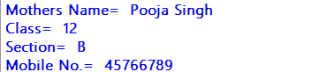

FRONT END-Office Access

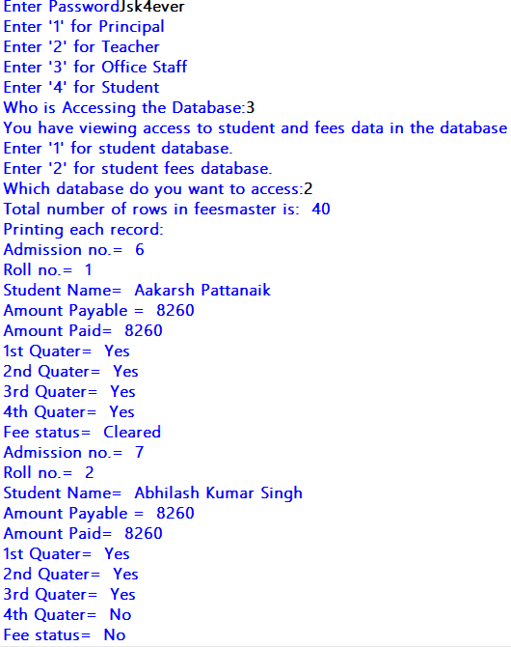

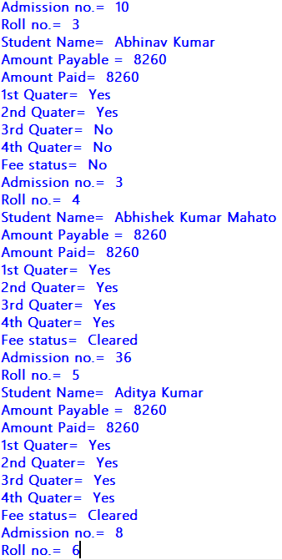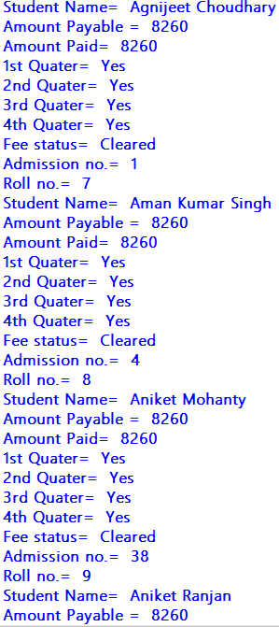

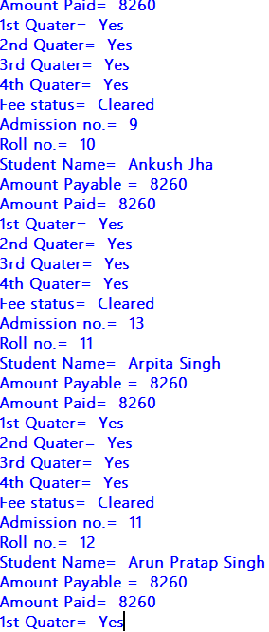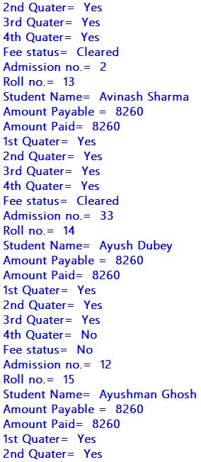

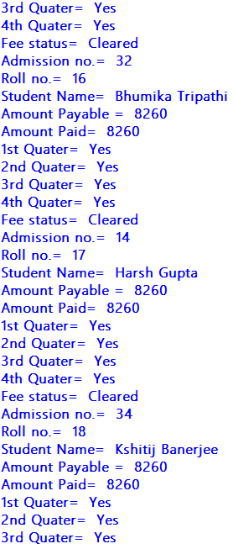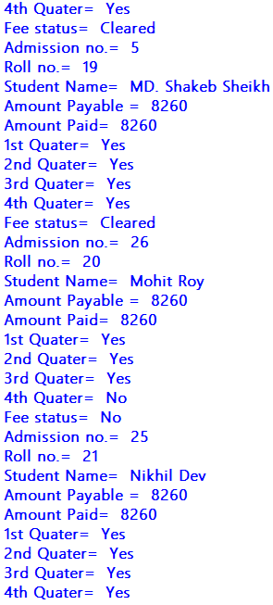

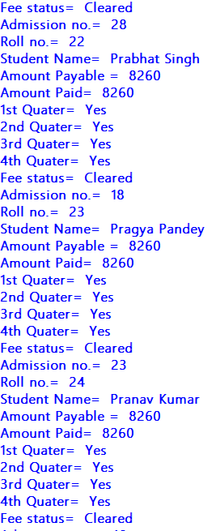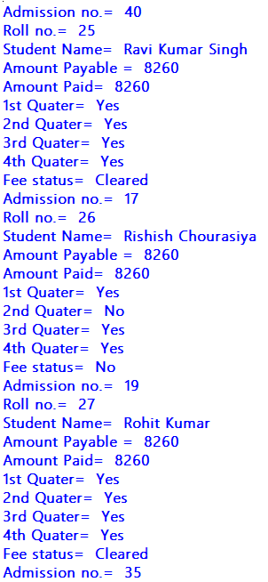

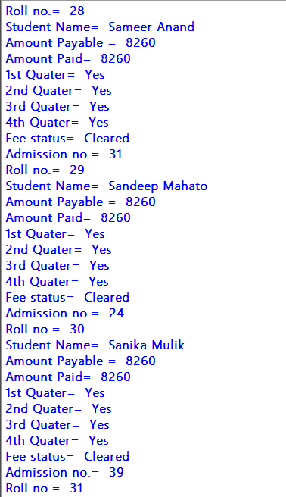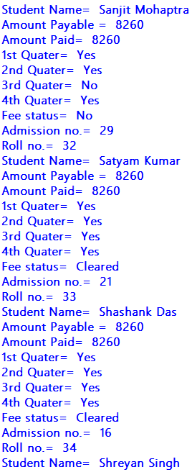

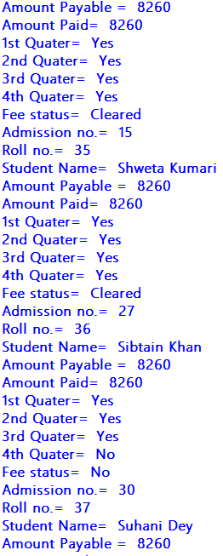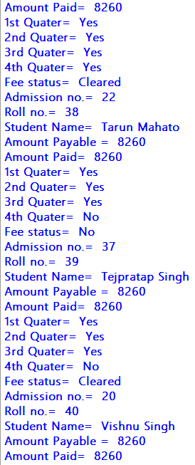

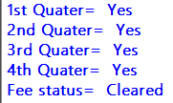

FRONT END-Student Access

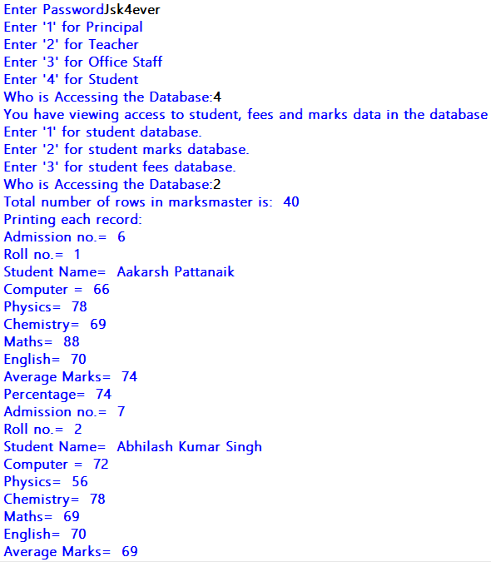

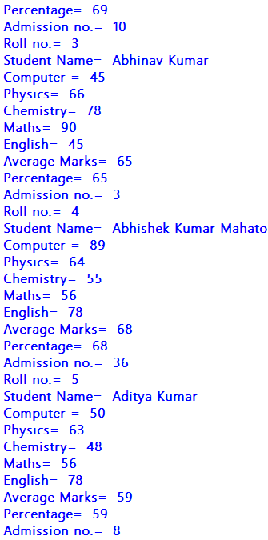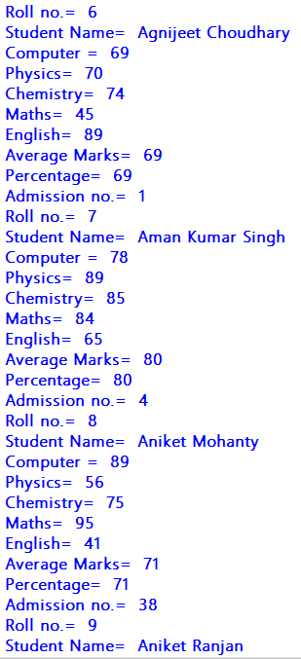

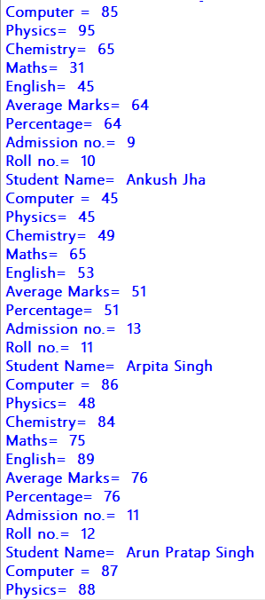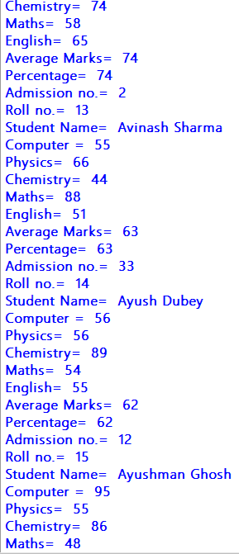

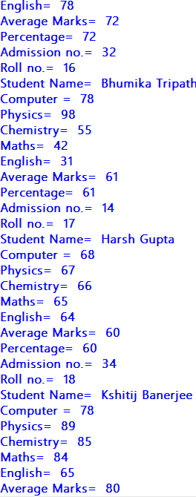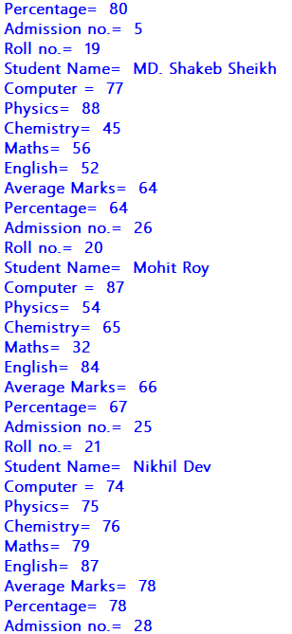

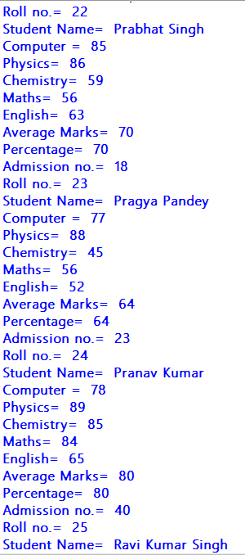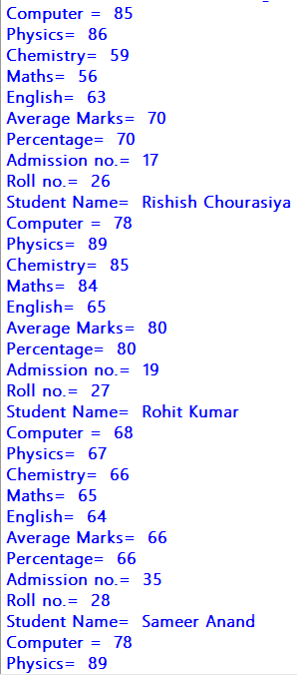

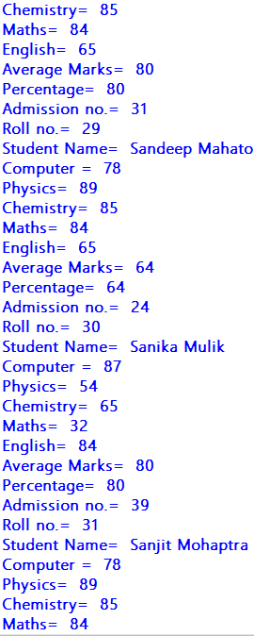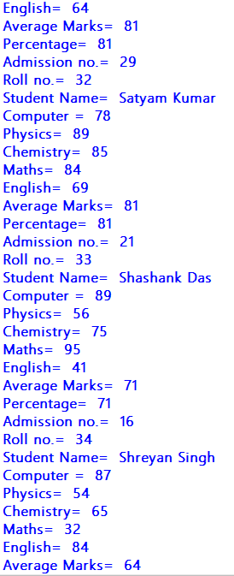

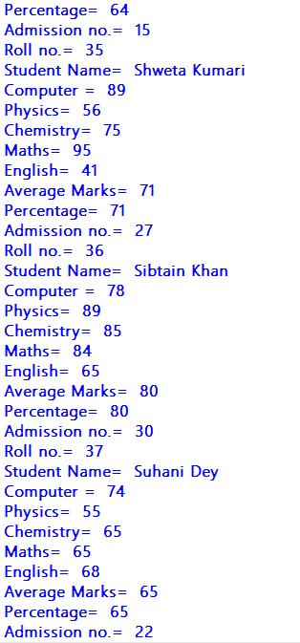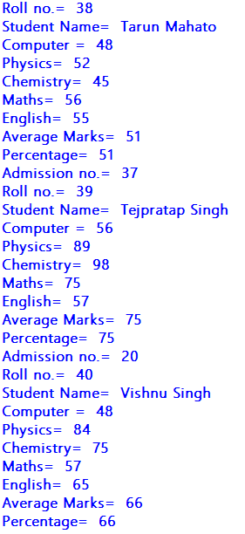

SOURCE CODE

FRONT-END CODE

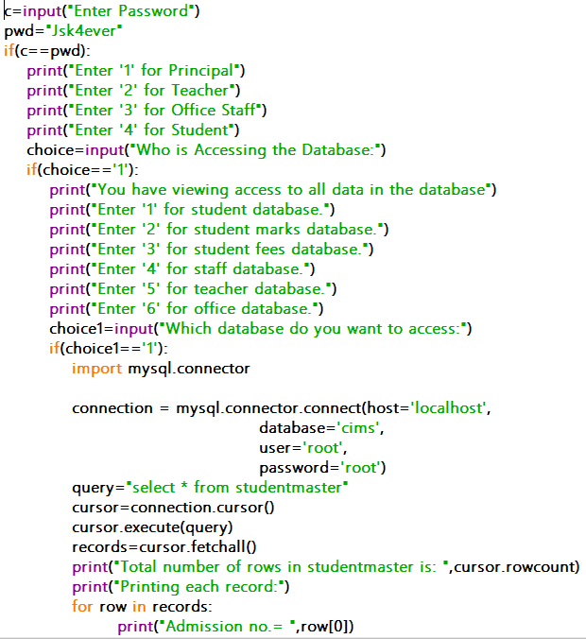

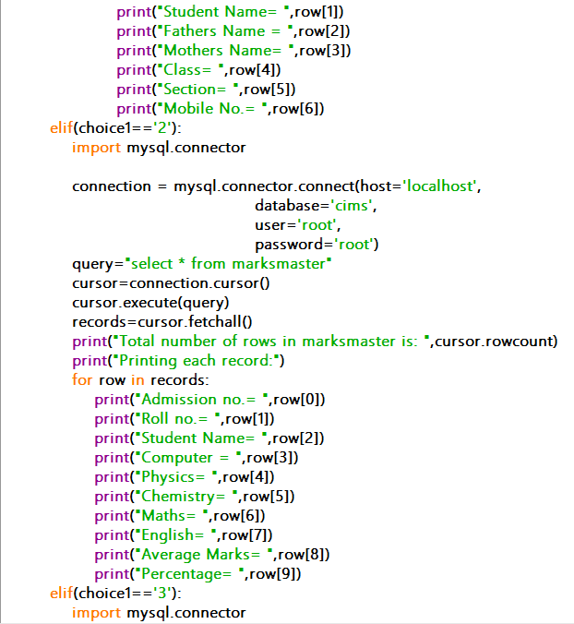

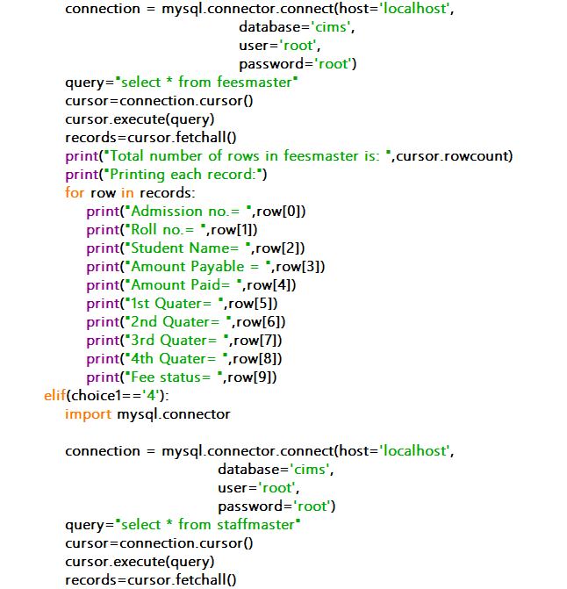

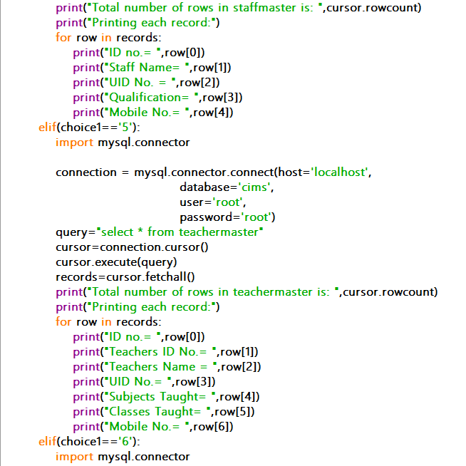

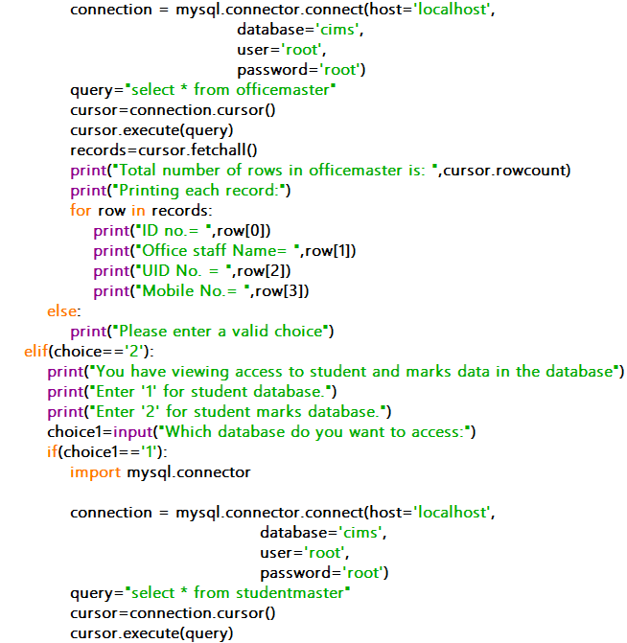

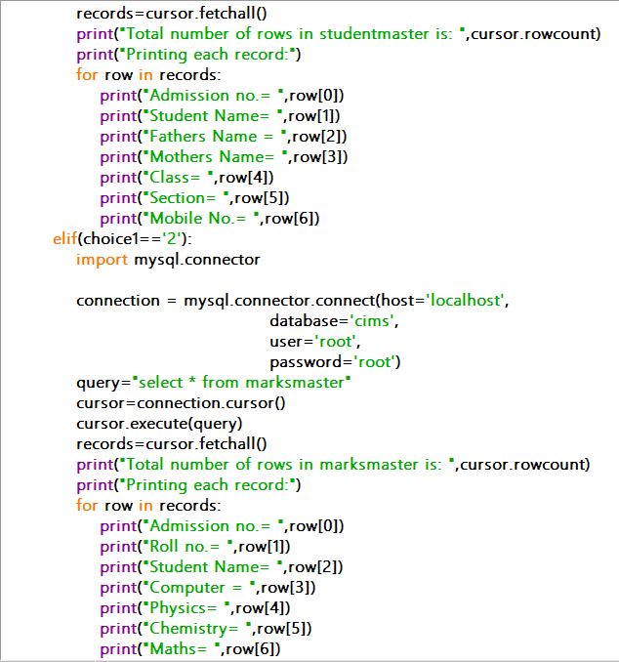

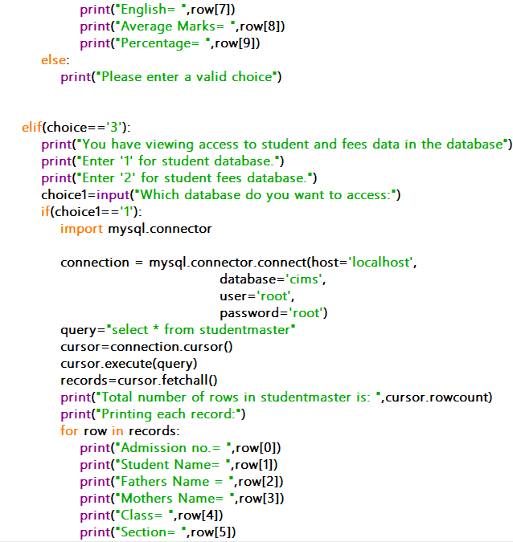

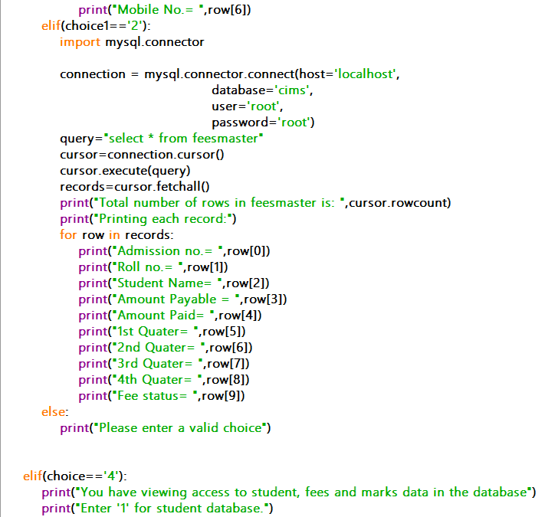

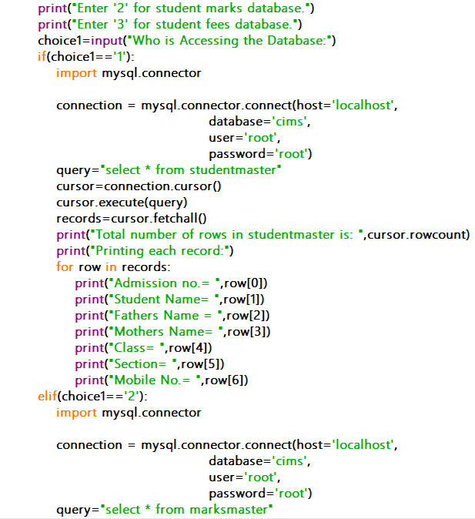

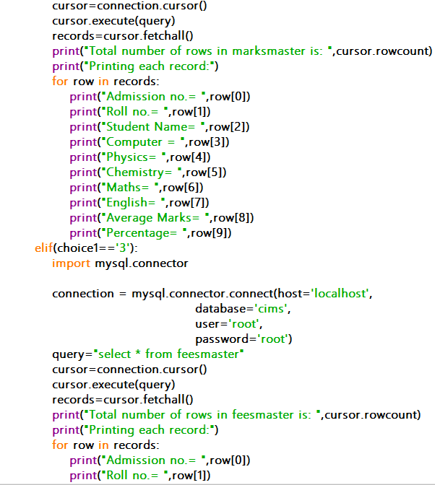

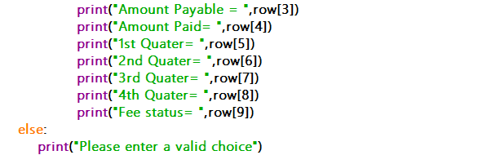

STUDENT TABLE

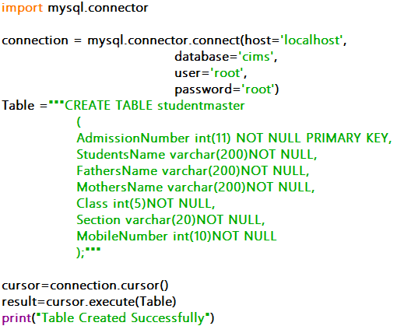

MARKS TABLE

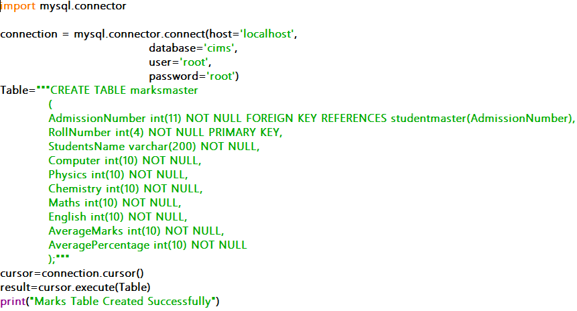

FEES TABLE

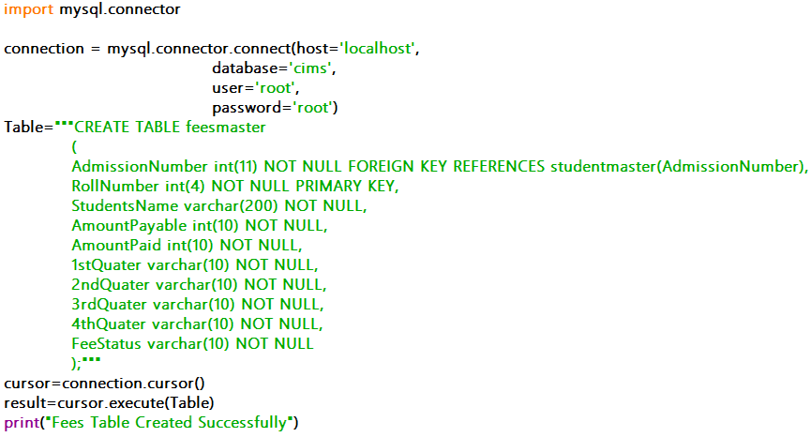

STAFF TABLE

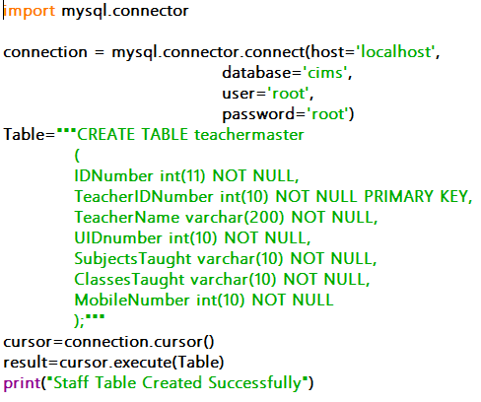

TEACHER TABLE

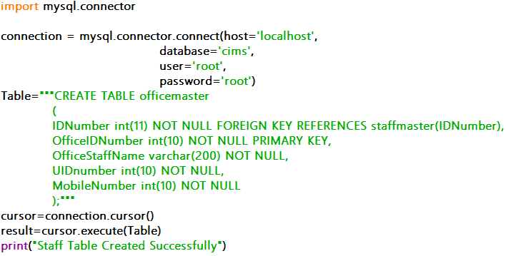

OFFICE MASTER

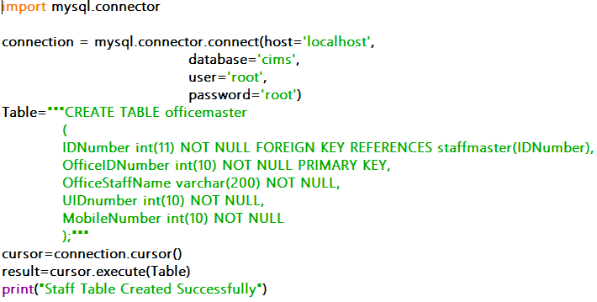

RECORD ENTRY

STUDENT TABLE

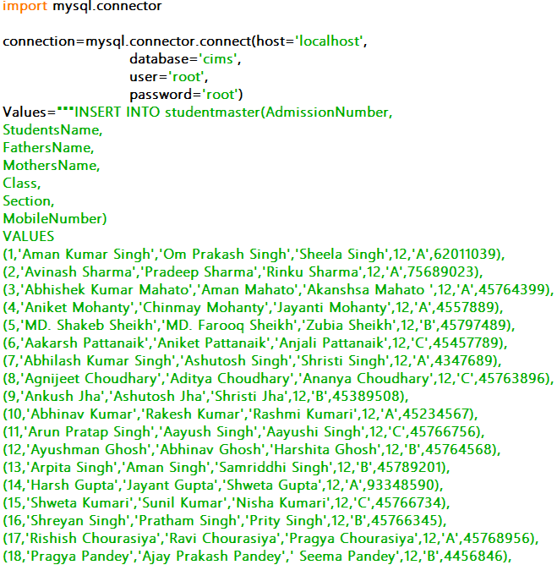

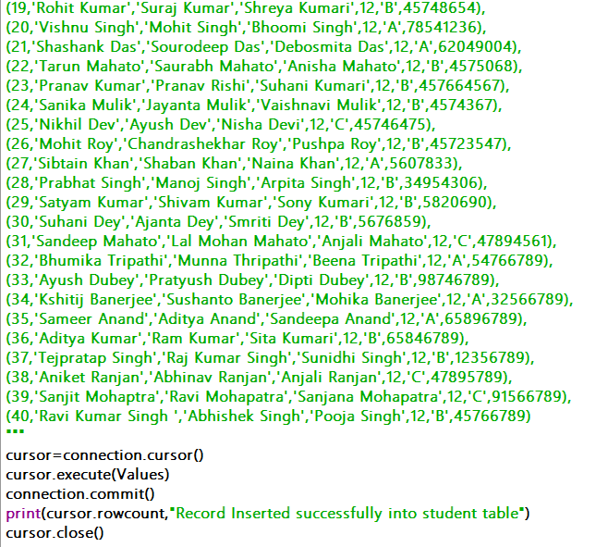

MARKS MASTER

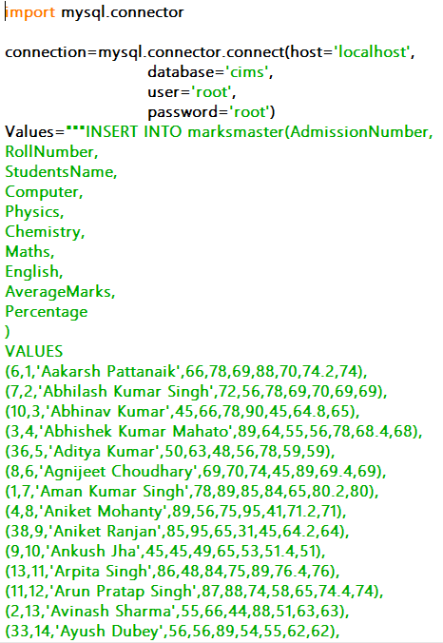

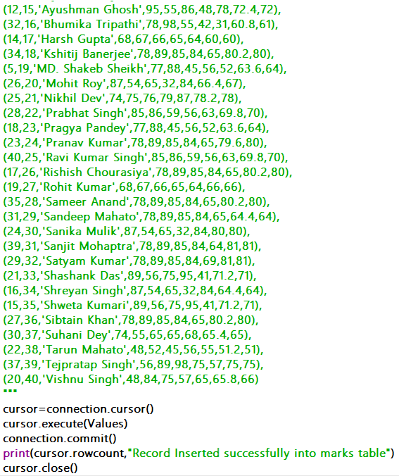

FEES TABLE

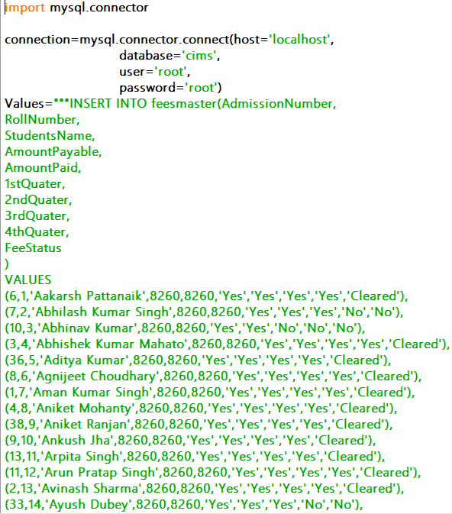

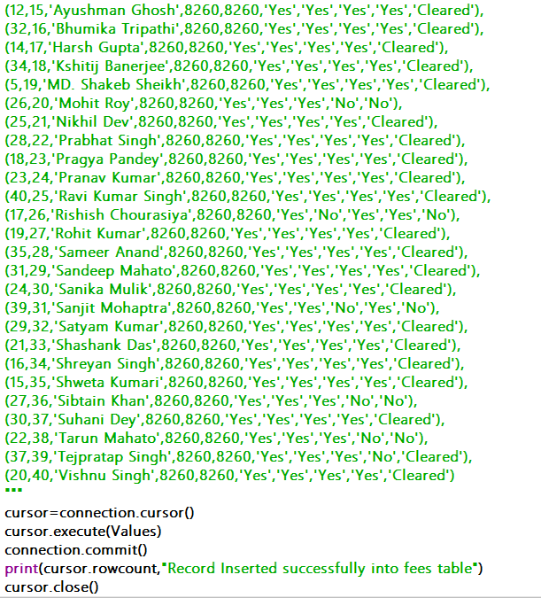

STAFF TABLE

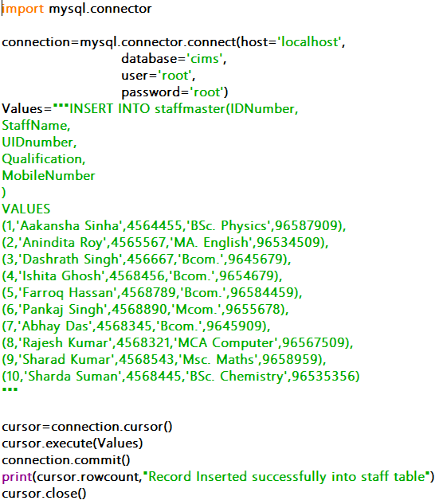

TEACHER TABLE

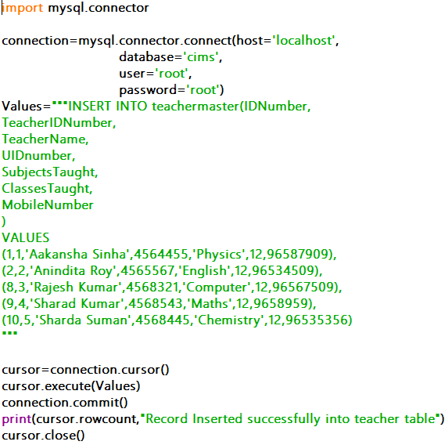

OFFICE TABLE

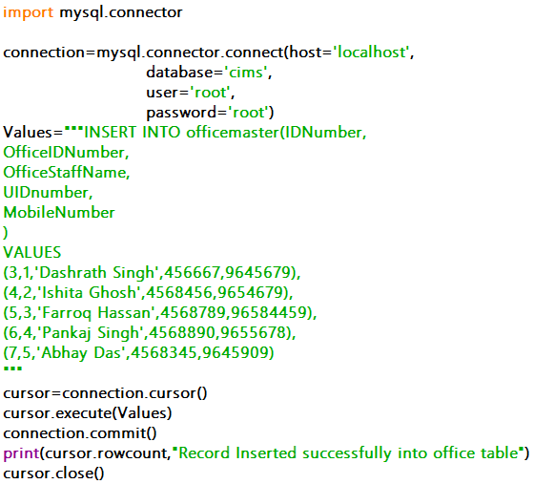

**CONCLUSION**

“Computer Institute Management System”, This project has every basic need of an Institute it includes everything, the data required to add any student is given. Everything entered can be accessed by the Principal of the Institute, The Teachers have access to the marks and the Office Staff have access to the fee details of the students, The students on the other hand can see their marks and their fee details. This project has a lot of potential for upgradation.

BIBLIOGRAPHY

I would like to thank Rajesh Sir, for providing me with this great opportunity of making this project. I would also mention the book that helped me that is Sumita Arora’s Class 12 Python textbook. The internet was also a great helper in this project.